**SOLVER PRODUCT MIX**

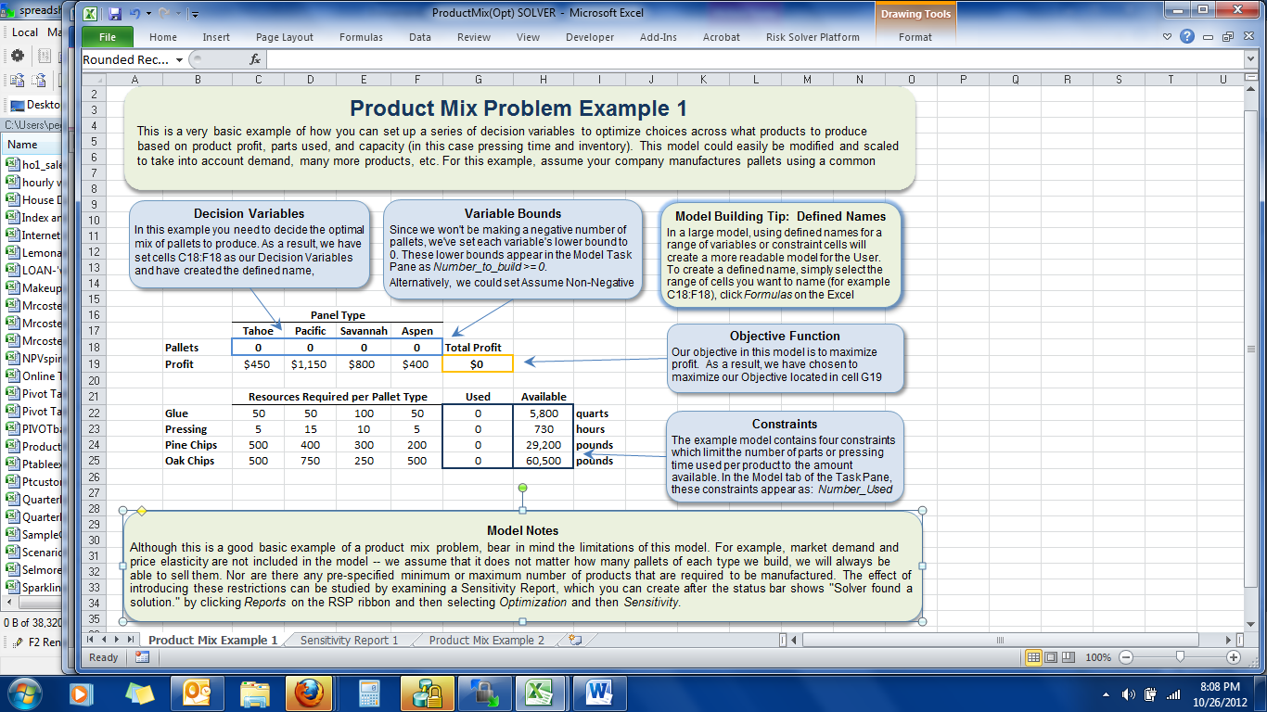

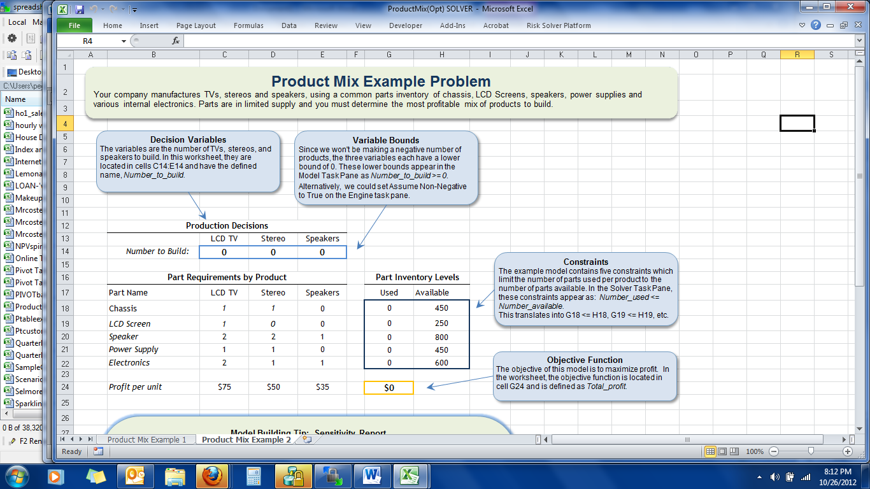

**Model Building Tip: Sensitivity Report**

A Sensitivity Report lists which constraints are binding or not binding. If a constraint is binding, the left hand side of the constraint is equal to its upper or lower bound or both, in the case of an equality. This means that in order to improve the objective, the constraint(s) must be relaxed. The Shadow Price is the change in the objective value of the optimal solution when the constraint is relaxed by one unit within the allowable increase or decrease.

To create a Sensitivity Report, press the green arrow on the Model task pane to run the Solver, then go to Reports > Optimization > Sensitivity on the RSP ribbon. A Sensitivity Report will be inserted directly to the left of this worksheet.

This report shows that at the optimal solution, we use all 800 Speaker Cones and 600 Electronics units, but not all of the additional components such as Chassis, LCD Screens or Power Supplies. In addition, we shoud produce 200 TVs and 200 Stereos but no Speakers. What do the *shadow prices* of the two "binding" constraints and the *reduced cost* of the one "nonbasic" variable tell us?

The shadow price of 12.5 for Speaker Cones tells us that we could increase Total Profits by $12.50 for every additional Speaker Cone we can acquire, up to 100 more. Similarly, the shadow price of 25 for Electronics units tells us we could use up to 50 more units and increase Total Profits by $25.00 for each extra unit.

The reduced cost of -2.5 for E14 tells us that, if we were forced to produce some Speakers, we would reduce Total Profits by $2.50 for each Speaker we made (since we would give up production of an alternate more profitable product).